**Embedded Systems Lab [CS-16203]**

**Assignment 1**

**To be done using EdSim51 simulator:**

2. Write a program in assembly language to add two 8 bit numbers with various addressing modes:

-Direct Mode

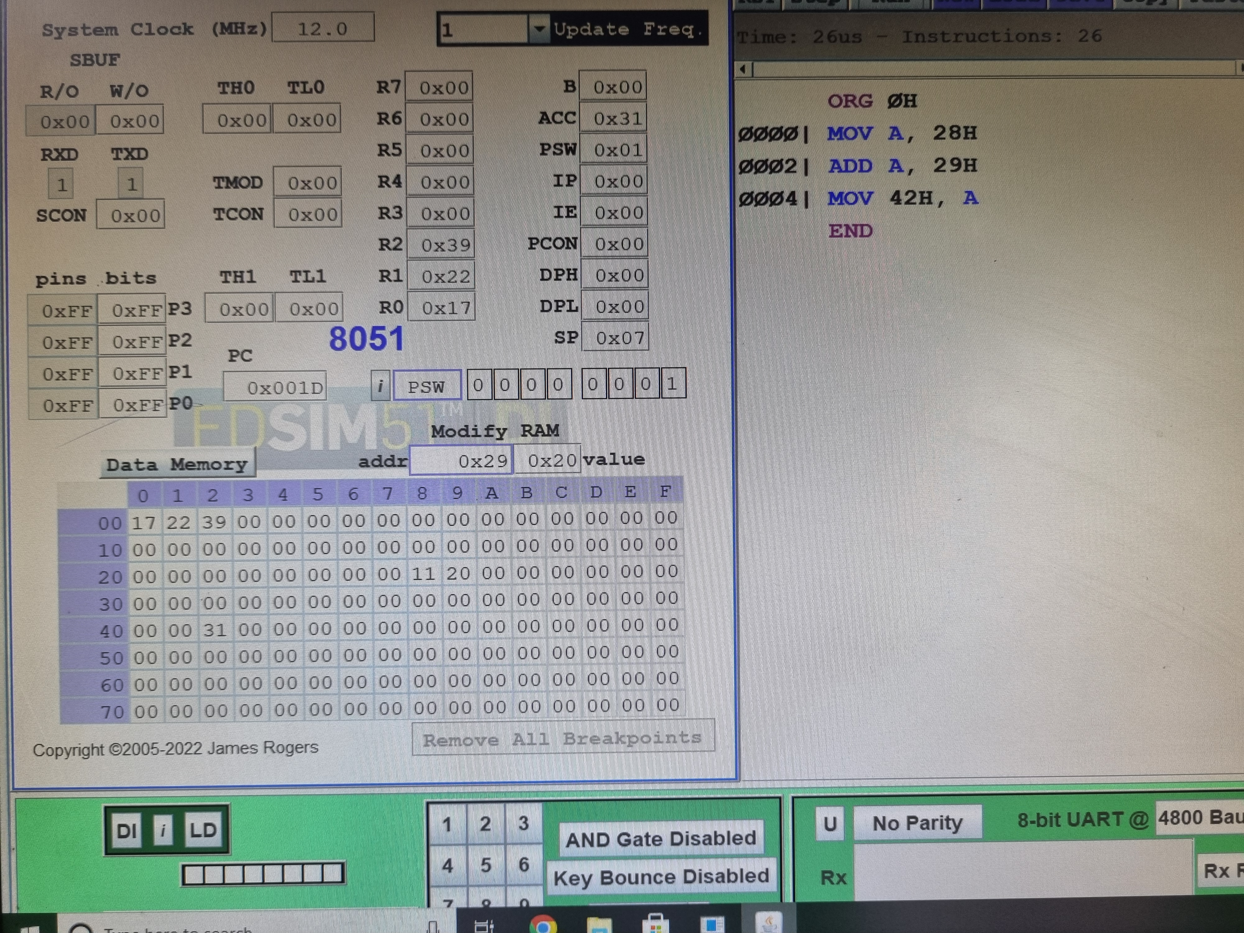

-Immediate Mode

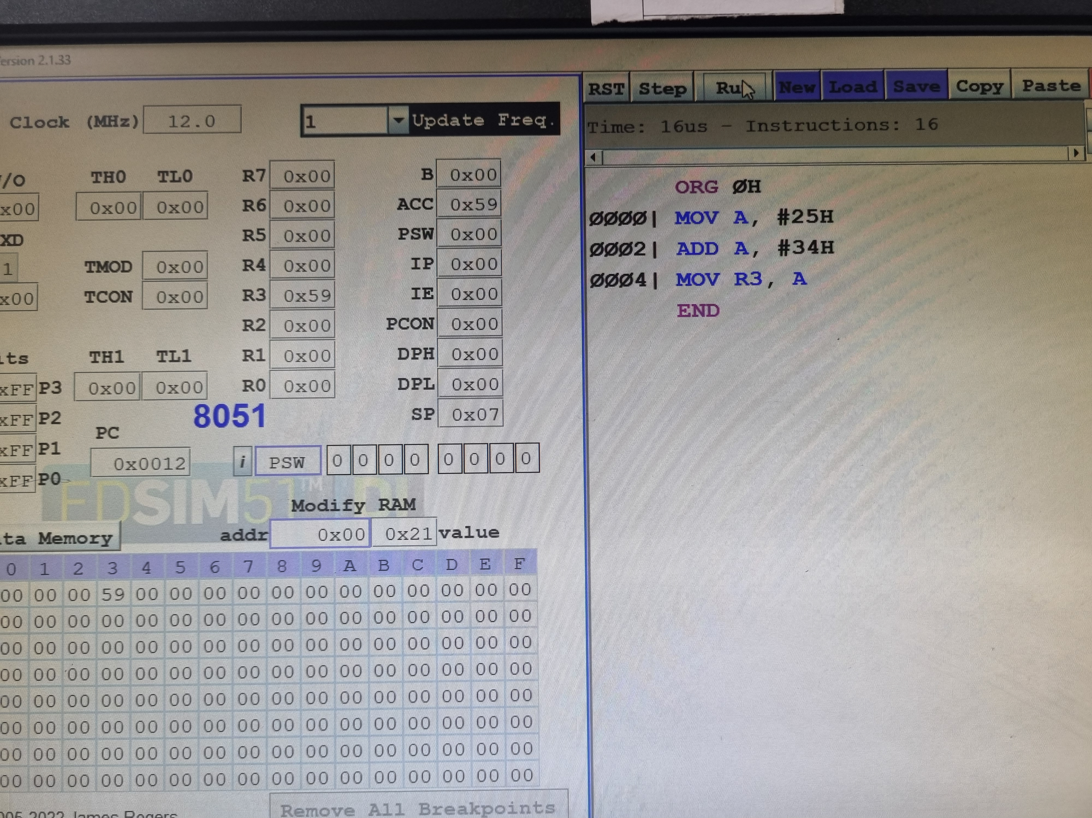

-Register Indirect Mode

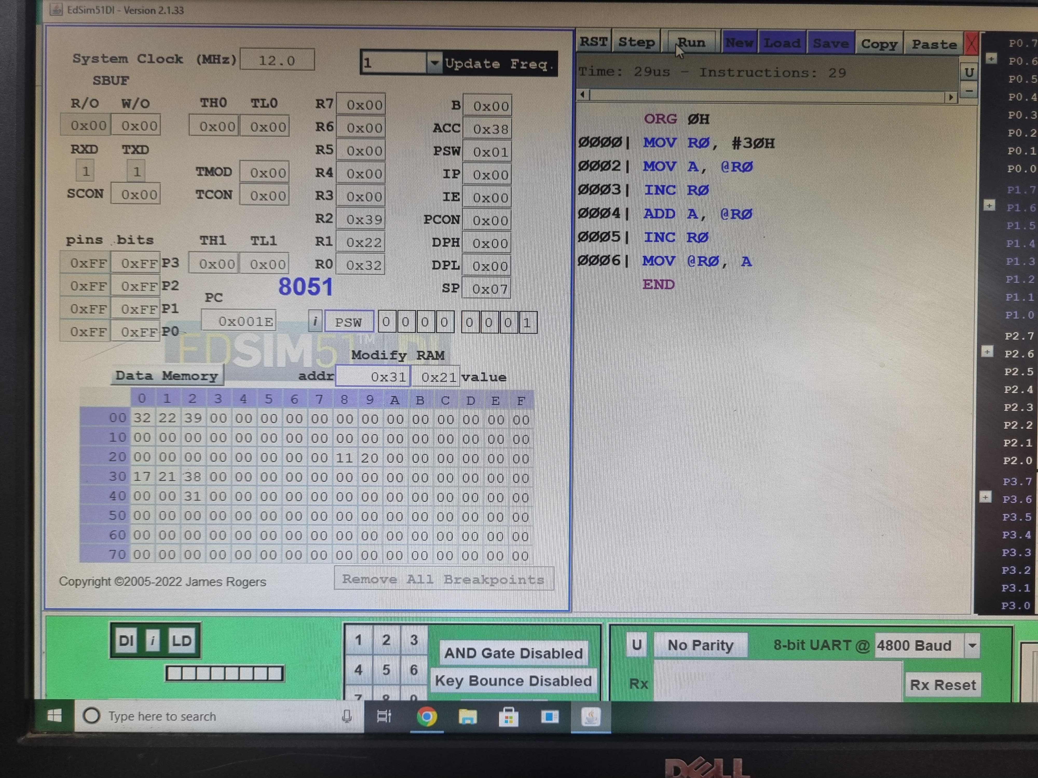

-Register Mode

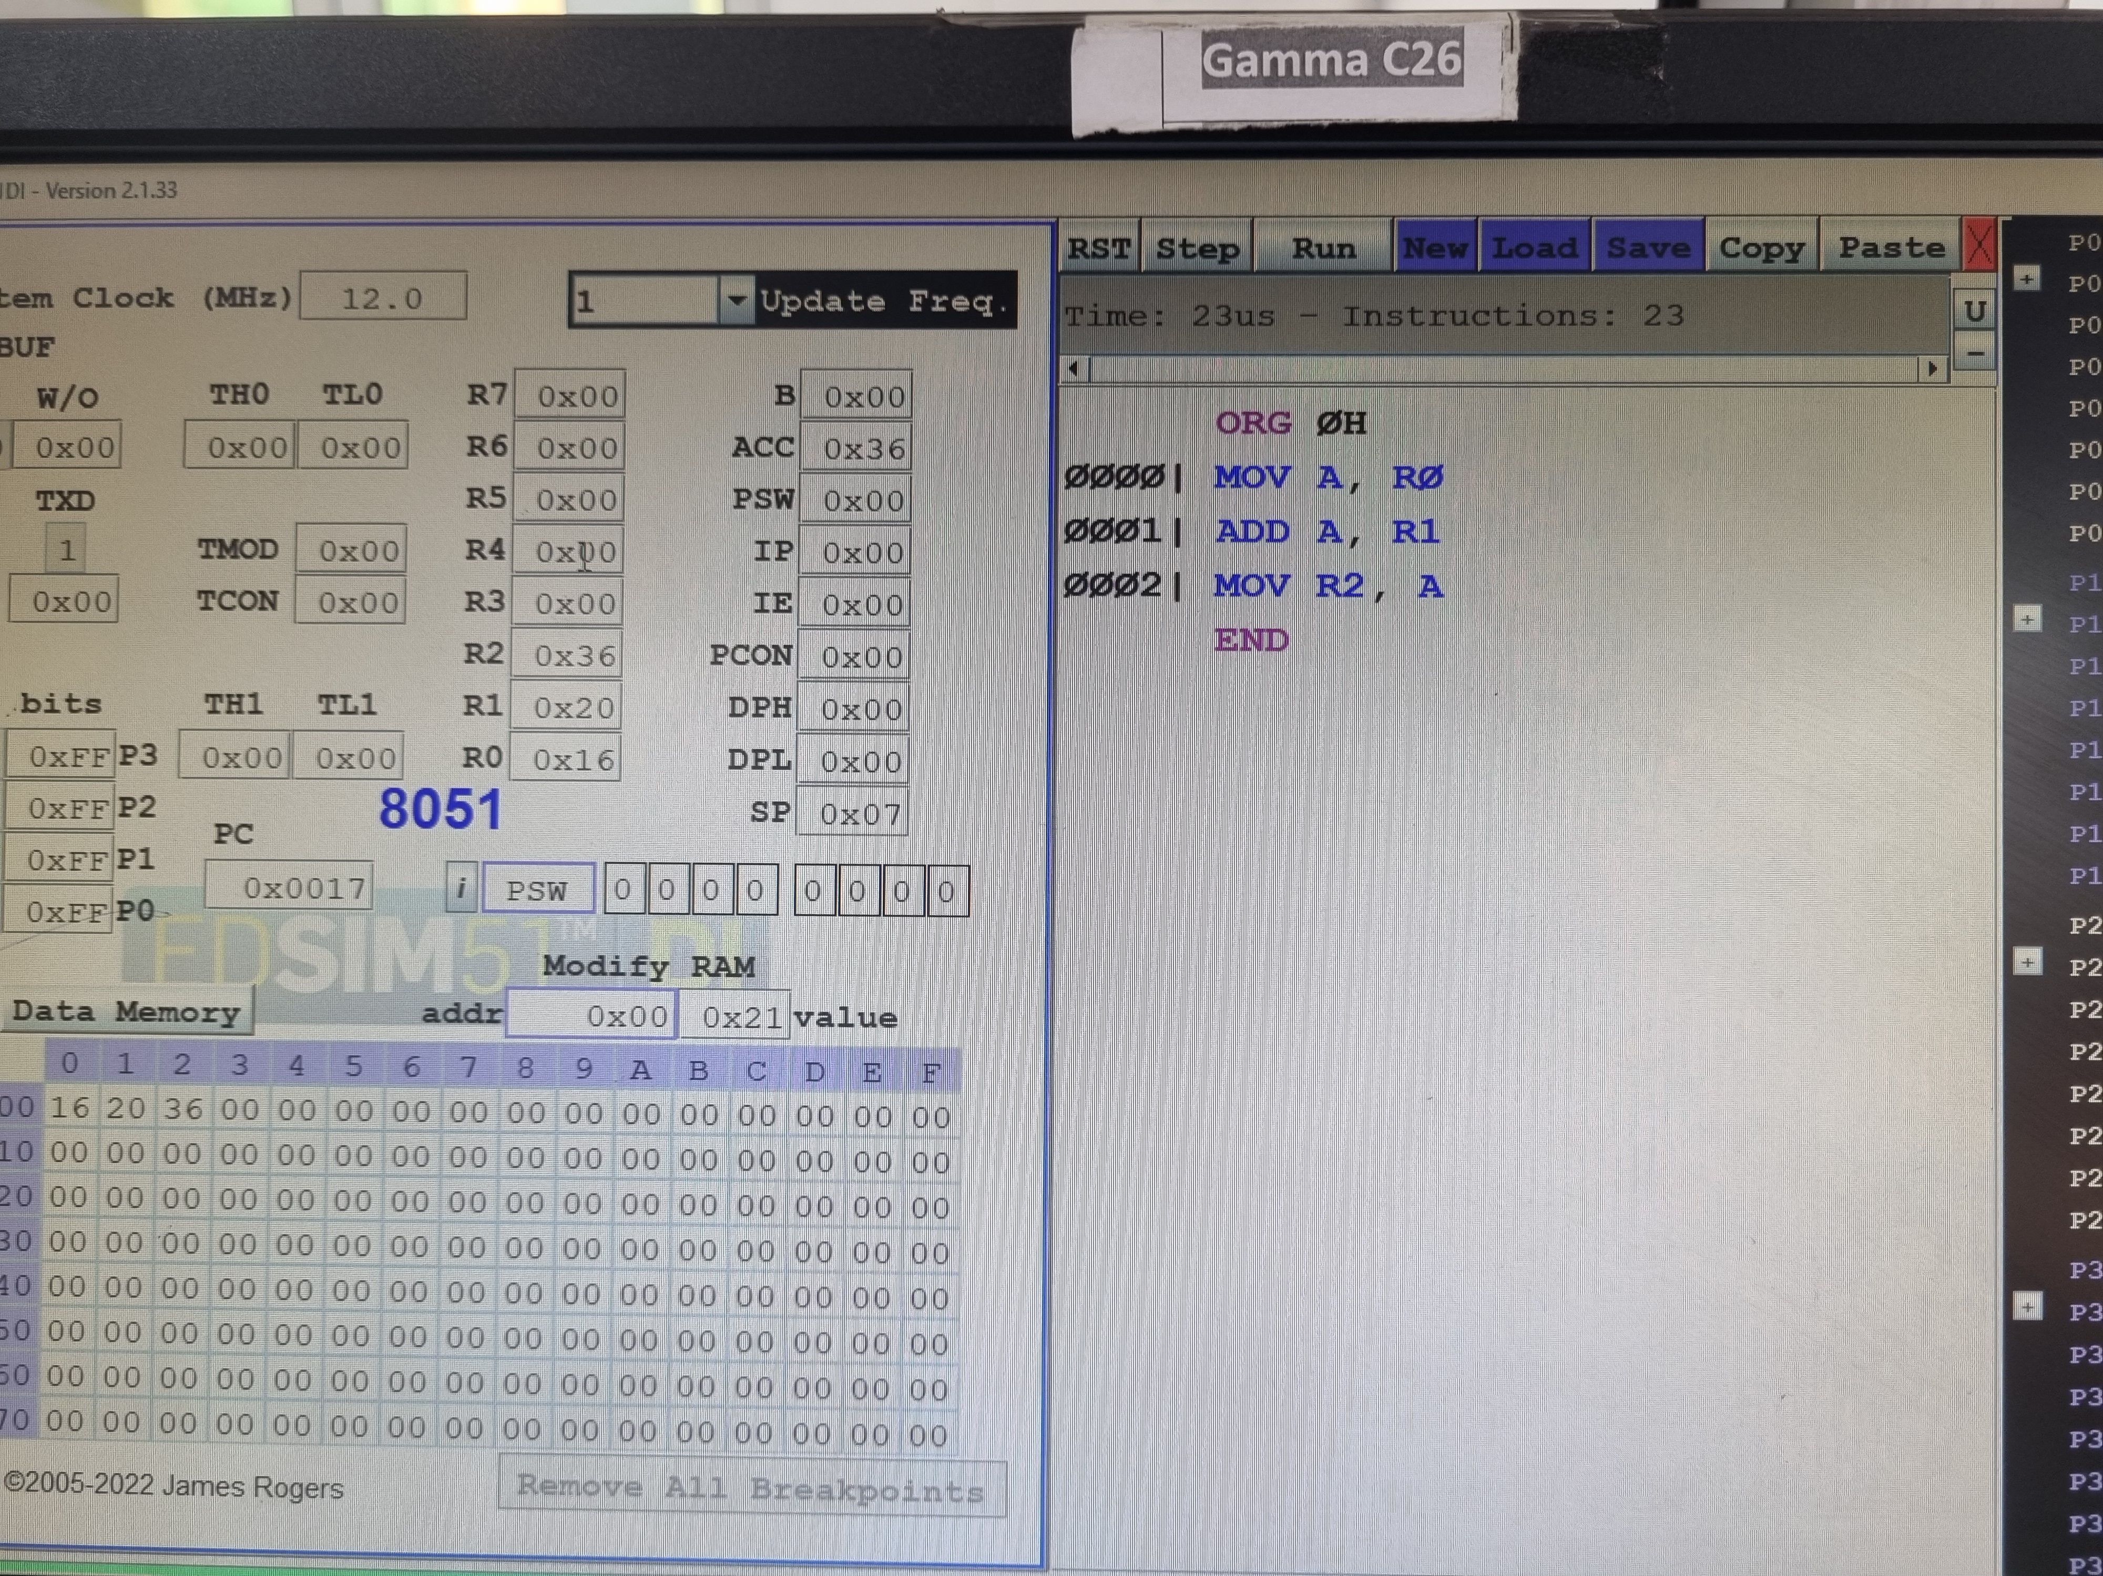

3. Write a program for subtractions, multiplication and division of two 8 bit numbers in assembly language.

Subtraction:

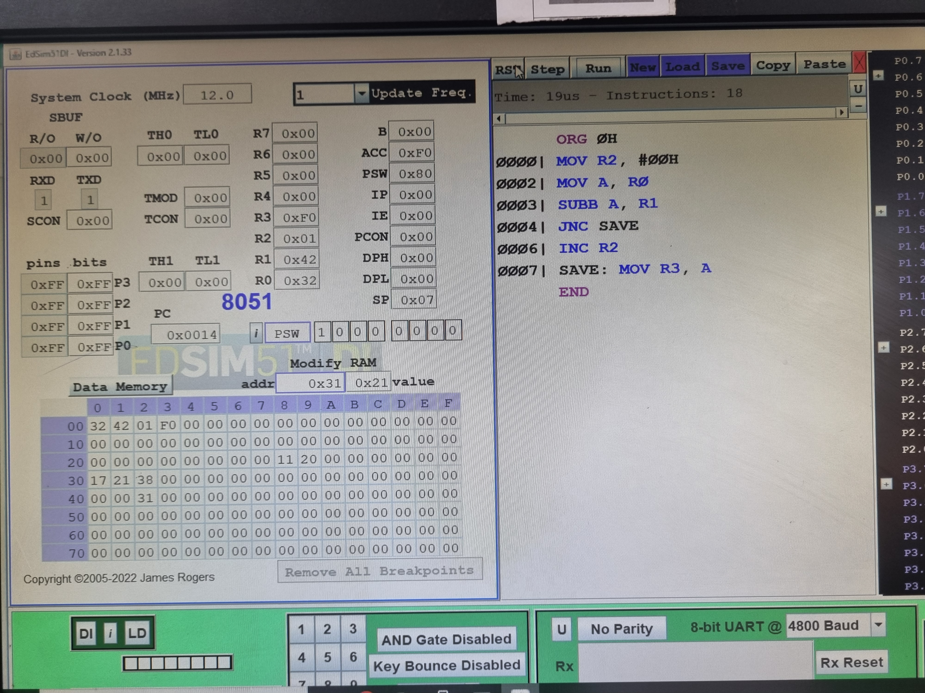

Multiplication:

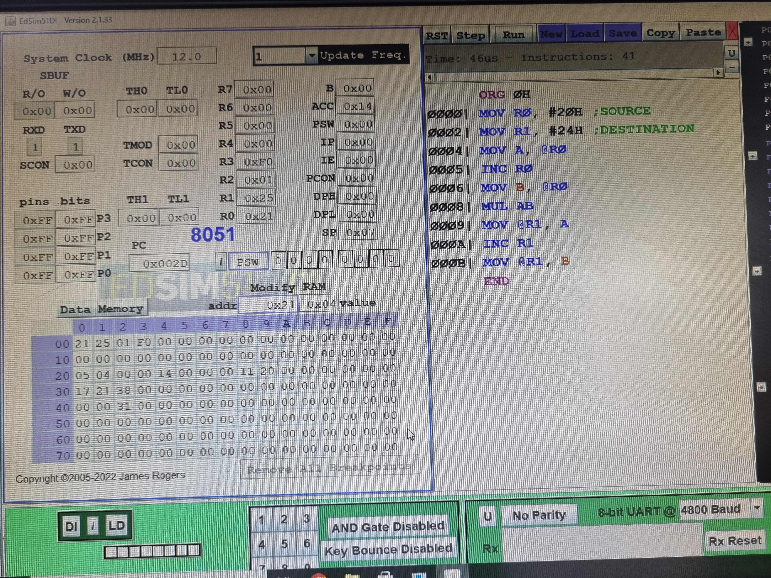

Division:

